GEE 1104 - PROGRAMMING FOR PROBLEM SOLVING
LABORATORY MANUAL

COURSE OBJECTIVES:
COB 1: To introduce the basic concepts of computing systems, software, hardware, and programming language evolution.
COB 2: To equip students with problem-solving skills using algorithms, flowcharts, and design strategies.
COB 3: To enable students to write structured C programs using variables, operators, control structures, and modular programming with functions.
COB 4: To gain skills to work with arrays, strings, structures, and unions for solving data manipulation problems.
COB 5: To provide an understanding of pointers, memory access, file operations, and advanced C programming constructs.
PRACTICALS:
SOFTWARE REQUIRED: C and C++ Compiler
- I/O statements and operators
- Decision Making statements
- Looping statements
- Single- and Two-dimensional Arrays
- String Operations
- Functions: call, return, passing parameters by (value, reference), passing
arrays to function
- Recursion
- Structures and Unions
- Pointers
- File operations in C using standard I/O functions.

TEXTBOOKS:
1. E. Balagurusamy, *Programming ANSI C*, 9th edition. New Delhi, India: McGraw Hill Education India, ISBN-13: 978-9355326720, 2024.
2. Y. Kanetkar, Let Us C: Authenticate guide to C Programming Language”, 20th edition. New Delhi, India: BPB Publications, ISBN 3. 13 978-9355515513, 2024
3. Thomas H. Cormen, Charles E. Leiserson, Ronald L. Rivest, Clifford Stein, “Introduction to Algorithms”, 4th edition, ISBN-13: 9780262046305, 2022.
4. Nell Dale and John Lewis, “Computer Science Illuminated”, 7th Edition, Jones and Bartlett Learning, ISBN-13:9781284155617, 2020.
REFERENCES:
- Kernighan, B.W and Ritchie,D.M, “The C Programming language”, 2nd Edition, Pearson Education, ISBN:9789332549449, 2015.

2. Ashok. N. kamthane, “Computer Programming”, 1st Edition, Pearson Education,
ISBN: 978-8131704486, 2007.
COURSE OUTCOMES: The students who complete this course will be able to
CO1: Describe the fundamental components of a computing system, evolution of
programming languages, and program execution process.
CO2: Develop algorithms and flowcharts using standard problem-solving strategies such as divide and conquer, greedy, brute force, and dynamic Programming
CO3: Write programs in C using basic syntax, data types, operators, control structures, and functions including recursion.
CO4: Implement arrays, strings, structures, and unions to solve real-world programming problems.
CO5: Apply the concepts of pointers, file handling, command-line arguments, and preprocessor directives for efficient C programming.
CONTENTS
S.No. | List of Programs
1. | Write a C program to display “This is my first C Program”.
2. | Write a C program to find sum and average of three numbers.
3. | Write a C program to calculate area and circumference of a circle.
4. | Write a C program to input three numbers and display the maximum number.
5. | Write a C program to swap values of two variables with and without using third variable.
6. | Write a C program to display the size of every data type using “sizeof” operator.
7. | Write a C program to checks whether a user can vote or not using ternary operator.
8. | Write a C program to illustrate the use of unary prefix and postfix increment and decrement operators.
9. | Write a C program to check whether a given number is prime or not.
10. | Write a C program to check whether the entered year is leap year or not.
11. | Write a C program to find the factorial of a number.
12. | Write a C program to check number is Armstrong or not.  (Hint: A number is Armstrong if the sum of cubes of individual digits of a number is equal to the number itself).
13. | Write a C program to check whether a number is positive, negative or zero using switch case.
14. | Write a C program to calculate the sum of all elements in a matrix (2D array).
15. | Write a C program to add, subtract, multiply and divide two integers using user defined type function with return type.
16. | Write a C program to find sum of digits of the number using Recursive Function.
17. | Write a C Program to Calculate Total and Percentage marks of a student using structure.
18. | Write a C program to declare and initialize a union.
19. | Write a C program to input and print array elements using pointer.
20. | Write a program to create a file called emp.rec and store information about a person, in terms of his name, age and salary.

INSTRUCTIONS TO STUDENTS
Before entering the lab, the student should carry the following things: (MANDATORY)
1. Identity card issued by the college.
2. Class notes
3. Lab observation book
- Come to the laboratory in time. Students, who are late more than 15 min., will not be allowed to attend the lab.
- Students need to maintain 100% attendance in lab if not a strict action will be taken.
- All students must follow a Dress Code.
- Foods, drinks are NOT allowed inside the lab.
- All bags must be left at the indicated place.
- Refer to the lab staff if you need any help in using the lab.
- Lab records/ Observation need to be submitted on or before the date of submission.
4. 200 pages unruled note for observation. (No Record for this semester, so maintain the observation neatly till your semester end examination).
5. Aim, Algorithm, Program and Results should be in right side of the page; Flowchart and output should be on left side of the page.
6. Leave 2-3 pages for index. (will give the soft copy of the index later, u can take print and paste it in the front page of the observation note).

Ex.No: 1
Date:
To display “ This is my first C Program”
Aim:
To write a C program that displays the message “This is my first C program” on the screen.
Algorithm:
- Start the program.
- Include the header file <stdio.h>.
- Define the main() function.
- Use printf() to display the message.
- End the program.
Flowchart:
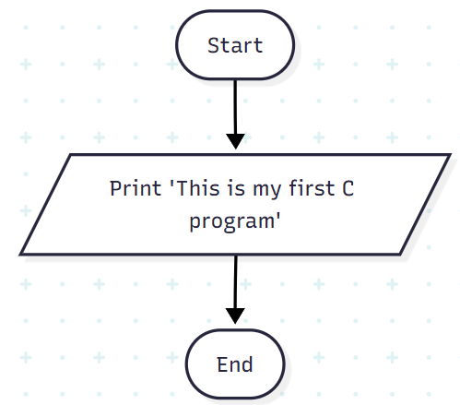
Program:
#include<stdio.h>
#include<conio.h>
int main()
{
printf("This is my first C program");
getch();
return 0;
}
Output:
This is my first C program
Result:
The program runs successfully and displays the message “This is my first C program” on the screen.
==================================================
Ex.No: 2
Date:
To find sum and average of three numbers
Aim:
To write a C program that calculates and displays the sum and average of three numbers.
Algorithm:
- Start the program.
- Include the header file <stdio.h>.
- Declare variables to store three numbers, their sum, and average.
- Input three numbers from the user.
- Calculate the sum of the three numbers.
- Calculate the average by dividing the sum by 3.
- Display the sum and average.
- End the program.
Flowchart:
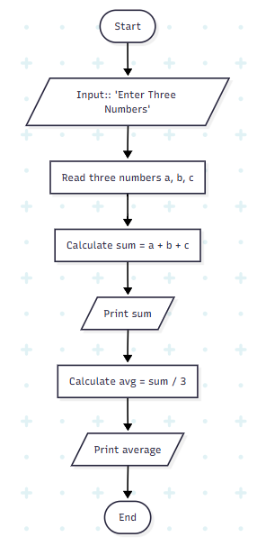
Program:
#include<stdio.h>
#include<conio.h>
int main()
{
int a,b,c, sum;
float avg;
printf("Enter Three Numbers : \n");
scanf("%d %d %d",&a, &b, &c);
sum = a + b +c;
printf("Sum of Three Numebers is : %d", sum);
avg=sum/3;
printf("\n Average of Three Numebers is : %f", avg);
getch();
return 0;
}
Output:
Enter Three Numbers :
10 2 38
Sum of Three Numebers is : 50
Average of Three Numebers is : 16.000000
Result:
The program executes successfully and displays the sum and average of the three numbers entered by the user.
==================================================
Ex.No: 3
Date:
To calculate area and circumference of a circle
Aim:
To write a C program that calculates and displays the area and circumference of a circle based on the radius entered by the user.
Algorithm:
- Start the program.
- Include the header file <stdio.h>.
- Declare variables for radius, area, and circumference.
- Input the radius of the circle from the user.
- Calculate the area using the formula: area = PI * radius * radius.
- Calculate the circumference using the formula: circumference = 2 * PI * radius.
- Display the calculated area and circumference.
- End the program.
Flowchart:
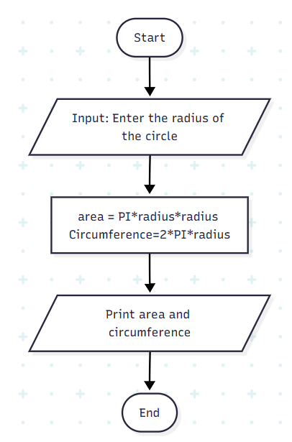
Program:
#include <stdio.h>
#include<conio.h>
#define PI 3.14159
int main()
{
int radius;
float area, circumference;
clrscr();
printf("Enter the radius of the circle: ");
scanf("%d", &radius);
area = PI * radius * radius;
circumference = 2 * PI * radius;
printf("Area of Circle = %.2f\n", area);
printf("Circumference of Circle = %.2f\n", circumference);
getch();
return 0;
}
Output:
Enter the radius of the circle: 5.25
Area of the circle: 86.59
Circumference of the circle: 32.99
Result:
The program executes successfully and displays the area and circumference of the circle for the radius entered by the user.

=================================================
Ex.No: 4
Date:
To find the greatest of three numbers using nested if –else
Aim:
To write a C program that finds and displays the greatest of three numbers using nested if-else statements.
Algorithm:
- Start the program.
- Include the header file <stdio.h>.
- Declare three variables to store the numbers.
- Input three numbers from the user.
- Compare the numbers using nested if-else statements
- If the first number is greater than the second and third, it is the greatest.
- Else if the second number is greater than the first and third, it is the greatest.
- Else the third number is the greatest.
- Display the greatest number.
- End the program.
Flowchart:

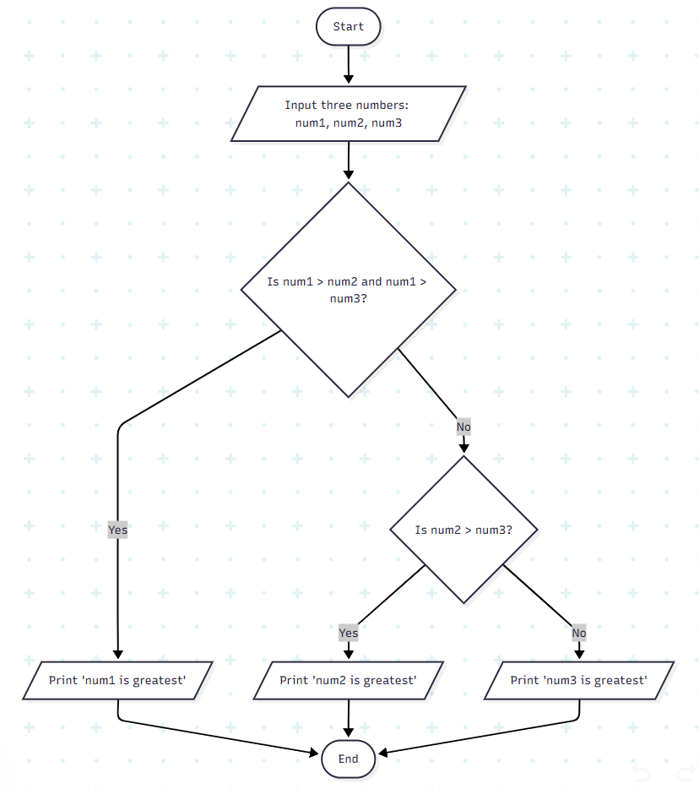
Program:
#include <stdio.h>
void main()
{
int num1, num2, num3;
printf("Enter three numbers:\n");
scanf("%d %d %d", &num1, &num2, &num3);
if (num1 >= num2 && num1 >= num3)
{
printf("num1: %d is largest\n", num1);
}
else if (num2 >= num1 && num2 >= num3)
{
printf("num2: %d is largest\n", num2);
}
else
{
printf("num3: %d is largest\n", num3);
}
}
Output:
Enter three numbers:
23 45 56
num3: 56 is largest
Result:
The program executes successfully and displays the greatest of the three numbers entered by the user.

==================================================

Ex No: 5 (a)

Date:

To Swap Two Values Using Temporary Variable

Aim:

To write a C program that swaps the values of two variables using a temporary variable and displays the result.

Algorithm:

- Start the program.

- Include the header file <stdio.h>.

- Declare two variables, say x and y, and a temporary variable temp.

- Input values of x and y from the user.

- Assign the value of x to temp.

- Assign the value of y to x.

- Assign the value of temp to y.

- Display the swapped values of x and y.

- End the program.

Flowchart:

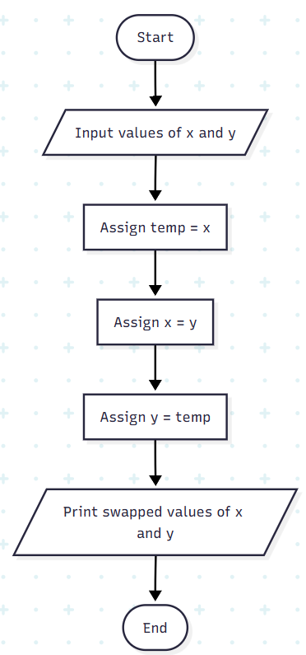

Program:

#include <stdio.h>
int main()
{
int x, y;
printf("Enter Value of x ");
scanf("%d", &x);
printf("\nEnter Value of y ");
scanf("%d", &y);
int temp = x;
x = y;
y = temp;
printf("\nAfter Swapping: x = %d, y = %d", x, y);
return 0; }

Output:

Values before swapping -
a = 11, b = 99
Values after swapping -
a = 99, b = 11

Result:

The program executes successfully and swaps the values of the two variables, displaying the updated values on the screen.

==================================================

Ex No: 5(b)

Date:

Swapping of Two Values Without Using Temporary Variable

Aim:

To write a C program that swaps the values of two variables without using a temporary variable and displays the result.

Algorithm:

- Start the program.
- Include the header file <stdio.h>.
- Declare two variables, say x and y.
- Input values of x and y from the user.
- Swap the values using arithmetic operations:
- x = x + y
- y = x - y
- x = x - y
- Display the swapped values of x and y.
- End the program.

Flowchart:

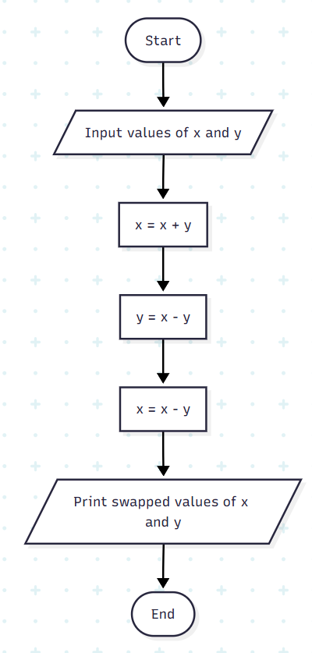
Program:
#include <stdio.h>
int main()
{
int x, y;
printf("Enter Value of x ");
scanf("%d", &x);
printf("\nEnter Value of y ");
scanf("%d", &y);
x = x+y;
y = x-y;
x = x-y;
printf("\nAfter Swapping: x = %d, y = %d", x, y);
return 0;
}

Output:

Values before swapping -
a = 11, b = 99
Values after swapping -
a = 99, b = 11

Result:
The program executes successfully and swaps the values of the two variables without using a temporary variable, displaying the updated values on the screen.

==================================================
Ex.No: 6
Date:
To display the size of every data type using the “sizeof” operator
Aim:
To write a C program that displays the memory size of various data types using the sizeof operator.
Algorithm:

- Start the program.
- Include the header file <stdio.h>.
- Declare variables of different data types (int, float, char, double, pointer(void *),etc.).
- Use the sizeof operator to find the size of each data type.
- Display the size of each data type on the screen.
- End the program.

Flowchart:
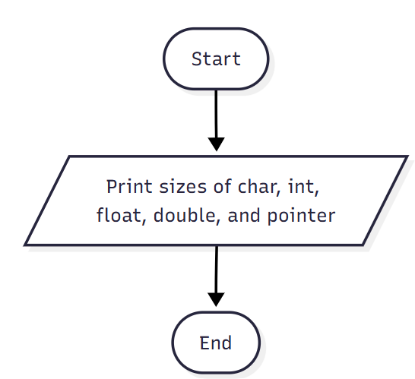
Program:
#include<stdio.h>
#include<conio.h>
int main(){
clrscr();
printf("Size of char: %lu bytes\n", sizeof(char));
printf("Size of int: %lu bytes\n", sizeof(int));
printf("Size of float: %lu bytes\n", sizeof(float));
printf("Size of double: %lu bytes\n", sizeof(double));
printf("Size of pointer: %lu bytes\n", sizeof(void *));
getch();
return 0;
}

Output:
Size of char: 1 bytes
Size of int: 4 bytes
Size of float: 4 bytes
Size of double: 8 bytes
Size of pointer: 8 bytes

Result:
The program executes successfully and displays the memory size (in bytes) of all standard C data types, such as int, float, char, double, and pointer.

==================================================
Ex.No: 7
Date:

To check whether a user can vote or not using a ternary operator

Aim:
To write a C program that determines whether a user is eligible to vote based on age using a ternary operator.
Algorithm:
- Start the program.
- Include the header file <stdio.h>.
- Declare a variable to store the user's age.
- Input the age from the user.
- Use the ternary operator to check:
- If age ≥ 18 → print " You are Eligible"
- Else → print " You are Not Eligible"
- End the program.
Flowchart:
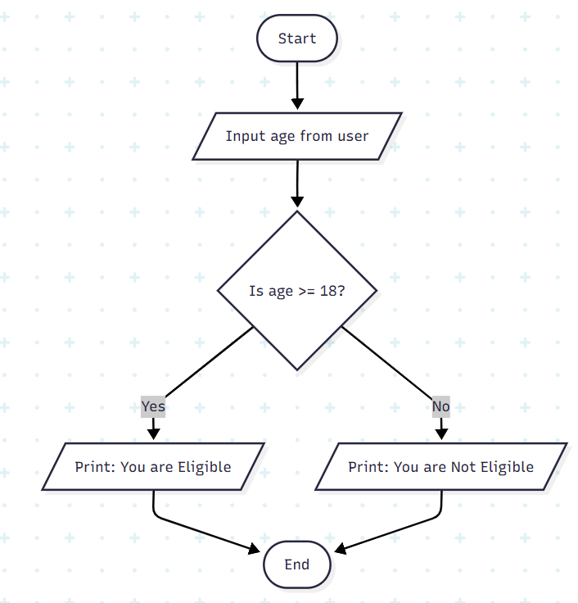

Program:
#include <stdio.h>
#include<conio.h>
int main() {
int age;
printf("Enter your age: ");
scanf("%d", &age);
(age >= 18) ? printf("You are Eligible.\n"): printf("You are Not Eligible.\n");
getch();
return 0;
}
Output:

Enter your age: 20
You are Eligible.

Result:
The program executes successfully and displays whether the user is eligible to vote based on the age entered.

==================================================

Ex.No: 8
Date:
The use of unary prefix and postfix increment and decrement operators

Aim:
To write a C program that demonstrates the use of unary prefix and postfix increment (++) and decrement (--) operators on integer variables.
Algorithm:
- Start the program.
- Include the header file <stdio.h>.
- Declare integer variables a, b, c, and d and initialize them with 5.
- Apply the unary operators:
  - a++ → postfix increment
  - ++b → prefix increment
  - c-- → postfix decrement
  - --d → prefix decrement
- Use printf() to display the updated values of a, b, c, and d.
- End the program.

Flowchart
:
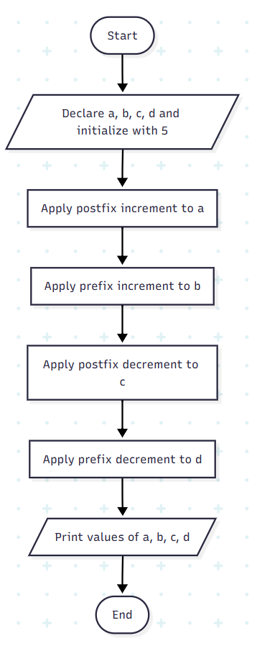
Program:
#include <stdio.h>

int main() {
int a = 5, b = 5, c = 5, d = 5;

a++; // postfix increment
++b; // prefix increment
c--; // postfix decrement
--d; // prefix decrement

printf("a = %d\n", a);
printf("b = %d\n", b);
printf("c = %d\n", c);
printf("d = %d\n", d);

return 0;
}

Output:

a = 6
b = 6
c = 4
d = 4

Result:
The program executes successfully and displays the updated values of the variables as a = 6, b = 6, c = 4, and d = 4.

==================================================

Ex.No: 9
Date:
To check whether a given number is prime or not
Aim:
To write a C program that checks whether a given number is prime or not.
Algorithm:
- Start the program.
- Include the header file <stdio.h>.
- Declare integer variables n, i, and flag (initialize flag = 0).
- Input the number n from the user.
- For loop from i = 2 to n/2:
- If n % i == 0, set flag = 1 and exit the loop.
- After the loop, check the flag:
- If flag == 0, the number is prime.
- Else, the number is not prime.
- Display the result.
- End the program.
Flowchart:
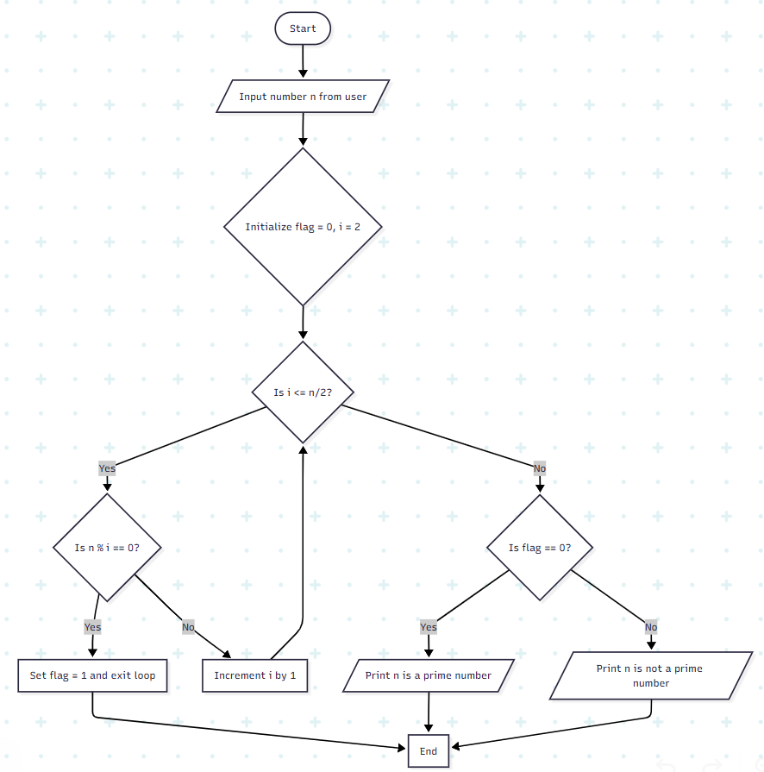
Program:
#include<stdio.h>
int main()
{

int n,i,flag=0;
printf("\nEnter a number:”);
scanf("%d",&n);
for(i=2;i<=n/2;i++)

{
if(n%i==0)

{flag=1; break;
}
}
if(flag==0)
printf(“%d is a prime number”,n);
else
printf(“%d is not a prime number”,n);
return(0);
}

Output:

Enter a number: 29

29 is a prime number

Result:
The program executes successfully and displays whether the entered number is prime or not.

==================================================

Ex.No: 10
Date:
To check whether the entered year is a leap year or not
Aim:
To write a C program that checks whether the entered year is a leap year or not.
Algorithm:
- Start the program.
- Include the header files <stdio.h> and <conio.h>.
- Declare an integer variable yr to store the year.
- Input the year from the user.
- Check the leap year condition:
- If (yr % 400 == 0) or (yr % 4 == 0 && yr % 100 != 0), the year is a leap year.
- Else, it is not a leap year.
- Display the result.
- End the program.

Flowchart:

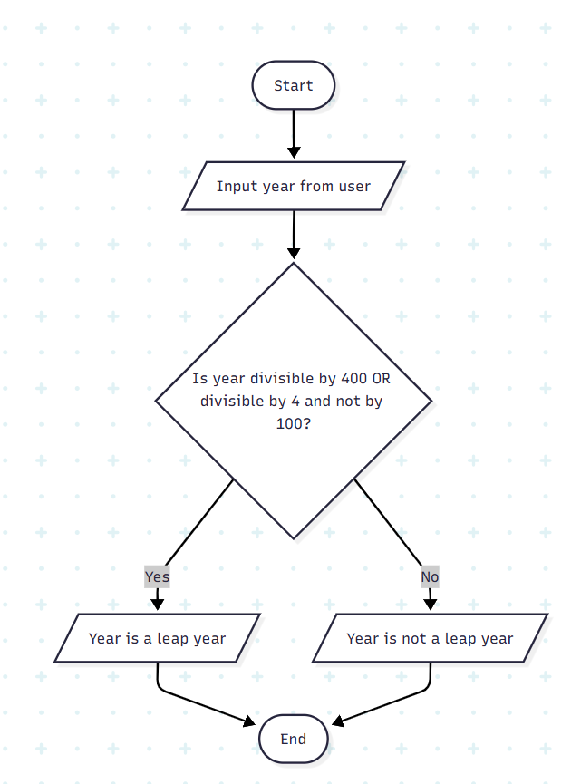
Program:
#include <stdio.h>
#include<conio.h>
int main()
{
int yr;
printf("\n Please Enter any number you wish \n ");
scanf("%d", &yr);
if (( yr%400 == 0)|| (( yr%4 == 0 ) &&( yr%100 != 0)))
printf("\n %d is a Leap. \n", yr);
else
printf("\n %d is not. \n", yr);
return 0;
}

Output:

Please Enter any number you wish
1300

1300 is not.

Result:
The program executes successfully and displays whether the entered year is a leap year or not.

==================================================

Ex.No: 11
Date:
To find the factorial of a number

Aim:
To write a C program that calculates and displays the factorial of a non-negative integer.

Algorithm:

- Start the program.
- Include the header file <stdio.h>.
- Declare integer variables n and i, and fact as unsigned long long initialized to 1.
- Input an integer n from the user.
- Check if n is negative:
- If yes, display an error message that factorial does not exist for negative numbers.
- Else, proceed to calculate factorial.
- Use a for loop from i = 1 to n:
- Multiply fact by i in each iteration.
- Display the factorial value.
- End the program.

Flowchart:
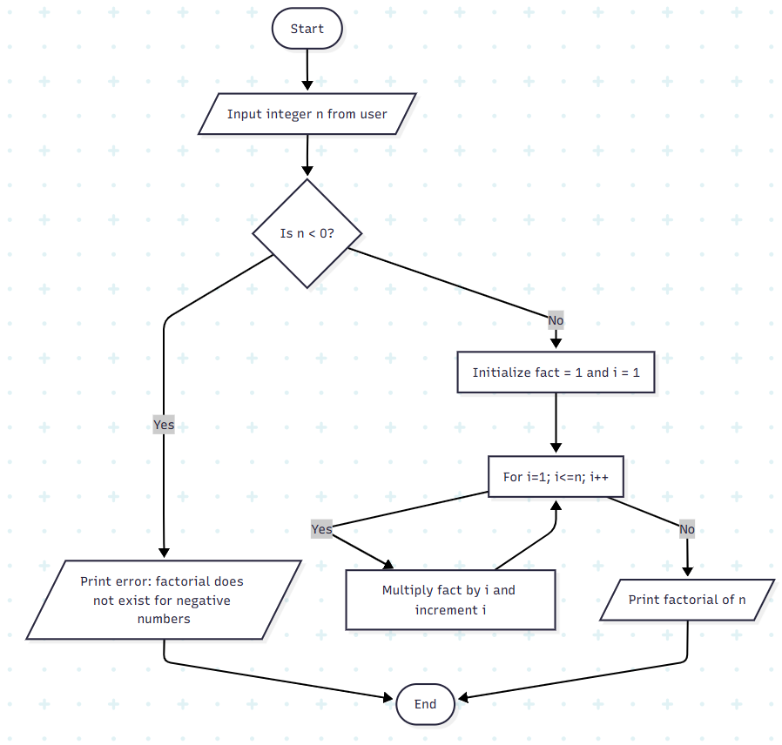
Program:
#include <stdio.h>
int main() {
int n, i;
unsigned long long fact = 1;
printf("Enter an integer: ");
scanf("%d", &n);

// shows error if the user enters a negative integer
if (n < 0)
printf("Error! Factorial of a negative number doesn't exist.");
else {
for (i = 1; i <= n; ++i) {
fact *= i;
}
printf("Factorial of %d = %llu", n, fact);
}
return 0;
}
Output:
Enter an integer: 10
Factorial of 10 = 3628800

Result:
The program executes successfully and displays the factorial of the entered non-negative integer or an error message if the number is negative.

Ex.No: 12

Date:

To check if the given number is Armstrong or not
Aim:
To write a C program that checks whether a given three-digit number is an Armstrong number or not.

Algorithm:

- Start the program.
- Include the header file <stdio.h>.
- Declare integer variables: num, originalNum, remainder, and result (initialize result = 0).
- Input a three-digit integer num from the user.
- Store num in originalNum.
- Use a while loop to extract digits of originalNum:
- Get the last digit using remainder = originalNum % 10.
- Add the cube of remainder to result.
- Remove the last digit from originalNum using originalNum /= 10.
- After the loop, check:
- If result == num, the number is an Armstrong number.
- Else, it is not an Armstrong number.
- Display the result.
- End the program.
Flowchart:
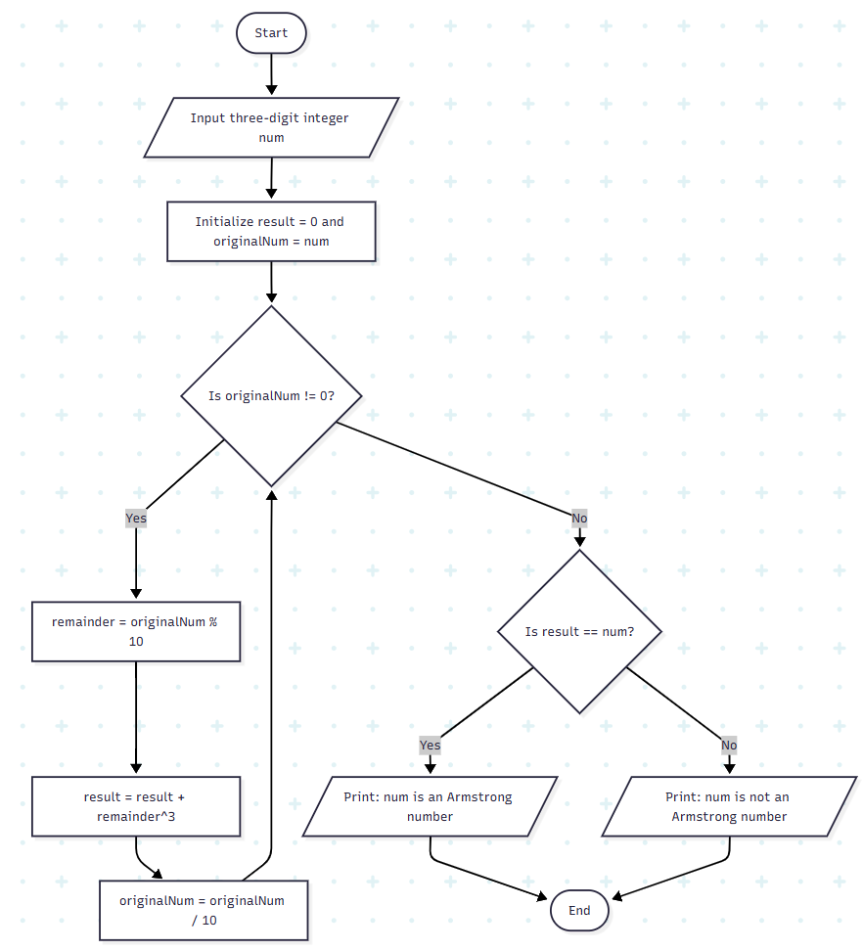

Program:
#include <stdio.h>
int main() {
int num, originalNum, remainder, result = 0;
printf("Enter a three-digit integer: ");
scanf("%d", &num);
originalNum = num;

while (originalNum != 0) {
// remainder contains the last digit
remainder = originalNum % 10;

result += remainder * remainder * remainder;

// removing last digit from the orignal number
originalNum /= 10;
}

if (result == num)
printf("%d is an Armstrong number.", num);
else
printf("%d is not an Armstrong number.", num);

return 0;
}

Output:

Enter a three-digit integer: 371
371 is an Armstrong number.

Result:

The program executes successfully and displays whether the entered number is an Armstrong number or not.

==================================================
Ex.No: 13
Date:

To check whether a number is positive, negative or zero using a switch case
Aim:
To check whether a given number is positive, negative, or zero using a switch-case statement in C.
Algorithm:

- Start the program.

- Read an integer input num from the user.

- Check if num is greater than 0 using switch(num > 0).

- If true (1), print "num is positive".

- If false (0), check if num is less than 0 using a nested switch.

- If true (1), print "num is negative".

- If false (0), print "num is zero".

- End the program.

Flowchart:
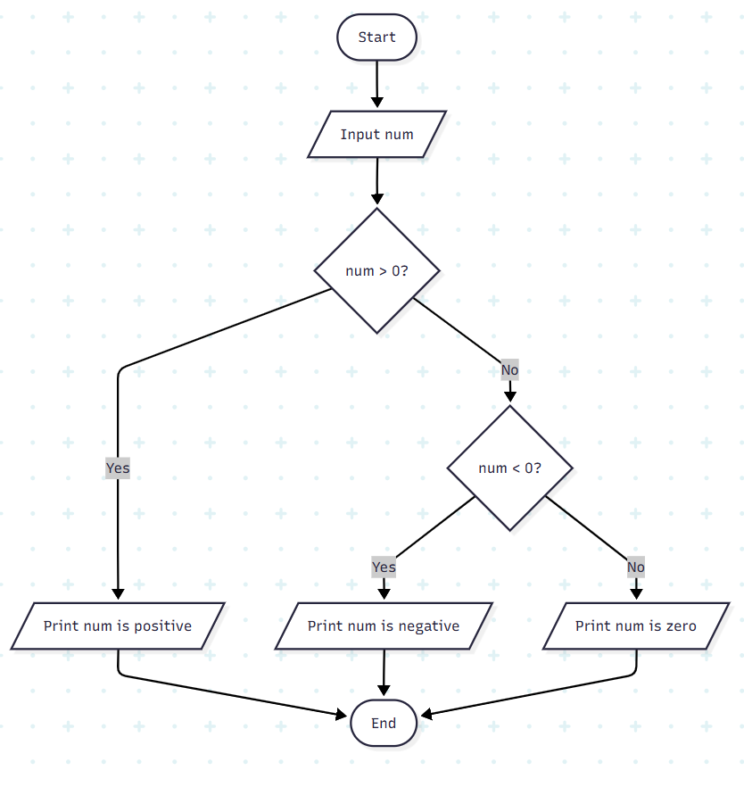
Program:
#include <stdio.h>

int main()
{
int num;

printf("Enter any number: ");
scanf("%d", &num);

switch (num > 0)
{
// Num is positive
case 1:
printf("%d is positive.", num);
break;

// Num is either negative or zero
case 0:
switch (num < 0)
{
case 1:
printf("%d is negative.", num);
break;
case 0:
printf("%d is zero.", num);
break;
}
break;
}
return 0;
}

Output:
Enter any number: 23
23 is positive.
Enter any number: -22
-22 is negative.
Enter any number: 0
0 is zero.
Result:
The program successfully classifies the entered number as positive, negative, or zero via switch-case statements.
==================================================
Ex.No: 14
Date:
To calculate the sum of all elements in a matrix (2D array)
Aim:
To calculate the sum of all elements of two matrices (2D arrays) of the same size and display the resulting matrix.

Algorithm:

- Start the program.
- Read the number of rows r and columns c.
- Input elements of the first matrix a.
- Input elements of the second matrix b.
- Initialize a sum matrix sum.
- For each element (i, j), calculate:
  - sum[i][j] = a[i][j] + b[i][j]
- Print the sum matrix.
- End the program.

Flowchart:
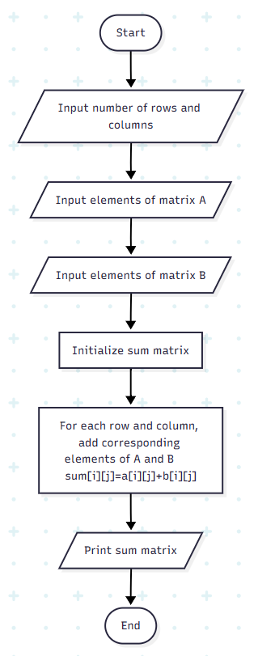
Program:
#include <stdio.h>
int main() {
int r, c, a[100][100], b[100][100], sum[100][100], i, j;
printf("Enter the number of rows (between 1 and 100): ");
scanf("%d", &r);
printf("Enter the number of columns (between 1 and 100): ");
scanf("%d", &c);
printf("\nEnter elements of 1st matrix:\n");
for (i = 0; i < r; ++i)
for (j = 0; j < c; ++j) {
printf("Enter element a%d%d: ", i + 1, j + 1);
scanf("%d", &a[i][j]);
}
printf("Enter elements of 2nd matrix:\n");
for (i = 0; i < r; ++i)
for (j = 0; j < c; ++j) {
printf("Enter element b%d%d: ", i + 1, j + 1);
scanf("%d", &b[i][j]);
}
// adding two matrices
for (i = 0; i < r; ++i)
for (j = 0; j < c; ++j) {
sum[i][j] = a[i][j] + b[i][j];
}
// printing the result
printf("\nSum of two matrices: \n");
for (i = 0; i < r; ++i)
for (j = 0; j < c; ++j) {
printf("%d ", sum[i][j]);
if (j == c - 1) {
printf("\n\n");
}
}
return 0;
}
Output:
Enter the number of rows (between 1 and 100): 2
Enter the number of columns (between 1 and 100): 2
Enter elements of 1st matrix:
Enter element a11: 1
Enter element a12: 2
Enter element a21: 3
Enter element a22: 4

Enter elements of 2nd matrix:
Enter element b11: 5
Enter element b12: 6
Enter element b21: 7
Enter element b22: 8
Sum of two matrices:
6 8
10 12
Result:
The program successfully adds two matrices element-wise to produce the sum matrix.

==================================================

Ex.No: 15
Date:
To add, subtract, multiply and divide two integers using user defined type function with return type
Aim:
To perform addition, subtraction, multiplication, division, and modulus of two integers using user-defined functions with return type in C.
Algorithm:
- Start the program.
- Read two integers num1 and num2 from the user.
- Define user-defined functions for each operation:
- addition(a, b) returns the sum of a and b.
- subtract(a, b) returns the difference of a and b.
- multiply(a, b) returns the product of a and b.
- division(a, b) returns the quotient of a divided by b.
- mod(a, b) returns the remainder of a divided by b.
- Call each function with num1 and num2 and display the result.
- End the program.

Flowchart:
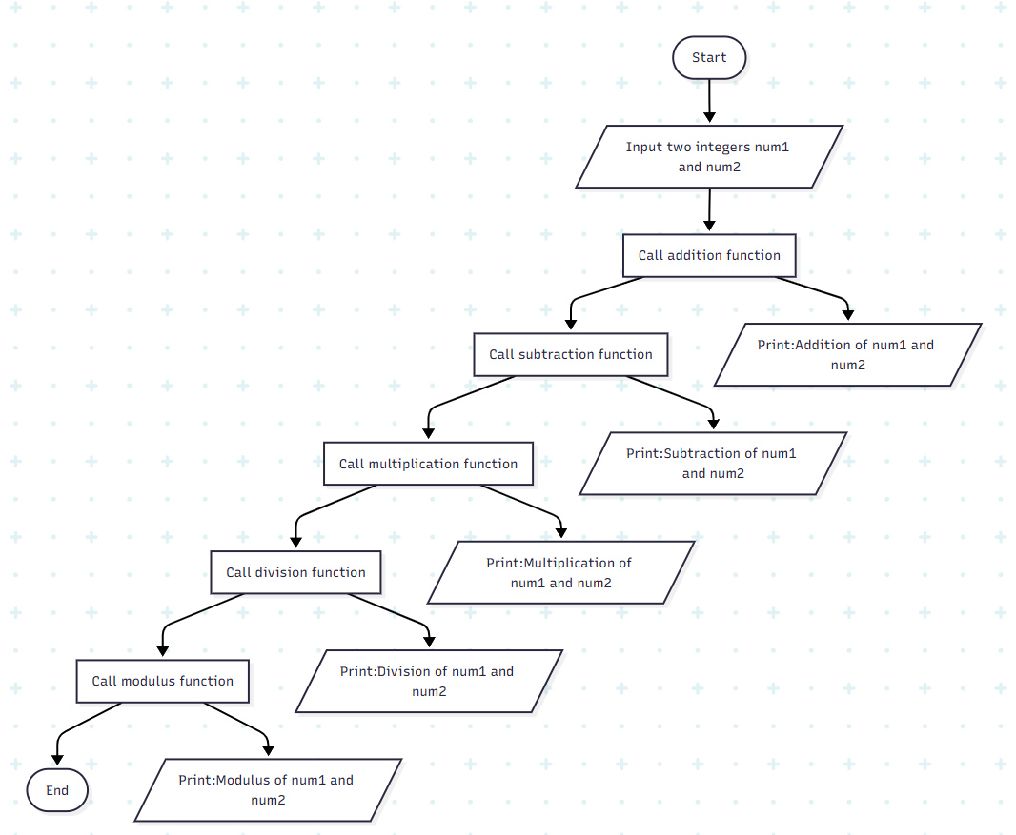

Program:
// C Program to Perform Arithmetic Operations Using Functions
#include <stdio.h>
// Declaring addition function
int addition(int a, int b){
int sum = a + b;
return sum;
}
// Declaring subtraction function
int subtract(int a, int b){
int difference = a - b;
return difference;
}
// Declaring multiplication function
int multiply(int a, int b){
int multiply = a * b;
return multiply;
}
// Declaring division function
float division(float a, float b){
float divide = a / b;
return divide;
}
// Declaring modulus function
float mod(int a, int b){
int rem = a % b;
return rem;
}
int main(){
int num1, num2;
// Asking for input
printf("Enter the first number: ");
scanf("%d", &num1);
printf("Enter the second number: ");
scanf("%d", &num2);
// Displaying output
printf("Arithmetic operations on %d and %d: \n", num1, num2);
printf("Addition: %d\n", addition(num1, num2));
printf("Subtraction: %d\n", subtract(num1, num2));
printf("Multiplication: %d\n", multiply(num1, num2));
printf("Division: %f\n", division(num1, num2));
printf("Modulus: %d\n", mod(num1, num2));
return 0;
}
Output
Enter the first number: 8
Enter the second number: 3
Arithmetic operations on 8 and 3:
Addition: 11
Subtraction: 5
Multiplication: 24
Division: 2.666667
Modulus: 3
Result:
The program correctly performs addition, subtraction, multiplication, division, and modulus operations using user-defined functions with return type.
==================================================
Ex.No: 16
Date:
To find the sum of digits of the number using Recursive Function
Aim:
To find the sum of digits of a given number using a recursive function in C.
Algorithm:
- Start the program.
- Define a recursive function sum_of_digit(n) that:
- Returns 0 if n == 0.
- Otherwise, returns (n % 10 + sum_of_digit(n / 10)).
- In the main function:
- Initialize an integer num.
- Call sum_of_digit(num) and store the result.
- Print the result.
- End the program.

Flowchart:
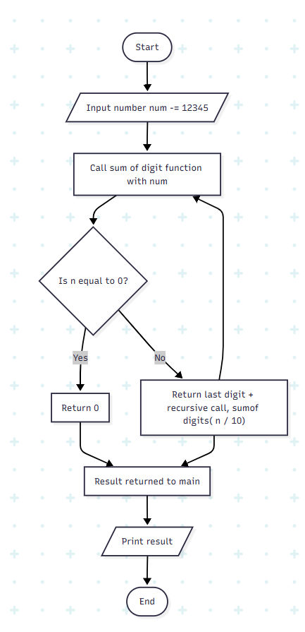
Program:
#include <stdio.h>
// Function to check sum of digit using recursion
int sum_of_digit(int n)
{
if (n == 0)
return 0;
return (n % 10 + sum_of_digit(n / 10));
}
// Driven Program to check above
int main()
{
int num = 12345;
int result = sum_of_digit(num);
printf("%d", result);
return 0;
}
Output:
15
Result:
Thus the program successfully calculates the sum of digits of the given number using recursion.
==================================================

Ex.No: 17
Date:
To Calculate Total and Percentage marks of a student using structure
Aim:
To create a program in C using structures to store student details (name, roll number, marks), and calculate their total marks and percentage using user-defined functions.
Algorithm:
- Start the program.
- Define a structure Student with members: name, rollNo, and marks[3].
- Create a function inputStudentData() to:
- Input name, roll number, and marks for 3 subjects.
- Return the student structure.
- Create a function calculateTotal(Student s) to:
- Add all 3 marks.
- Return the total.
- Create a function calculatePercentage(total) to:
  - Compute percentage as total / 3.
- In main:
- Call inputStudentData() to read student details.
- Call calculateTotal() and calculatePercentage().
- Display name, roll number, total marks, and percentage.
- End the program.

Flowchart:
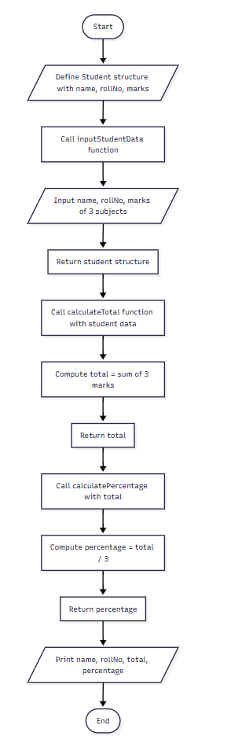

Program:
#include<stdio.h>
// Defining the Student structure
struct Student {
char name[50];
int rollNo;
int marks[3];
};
// Function to input student data
struct Student inputStudentData() {
struct Student s;
printf("Enter student's name: ");
scanf("%s", s.name);
printf("Enter roll number: ");
scanf("%d", &s.rollNo);
for(int i = 0; i < 3; i++) {
printf("Enter marks for subject %d: ", i + 1);
scanf("%d", &s.marks[i]);
}
return s;
}
// Function to calculate total marks
int calculateTotal(struct Student s) {
int total = 0;
for(int i = 0; i < 3; i++) {
total += s.marks[i];
}
return total;
}

// Function to calculate percentage
float calculatePercentage(int total) {
return (float)total / 3;
}
// Main function
int main() {
struct Student student = inputStudentData();
int total = calculateTotal(student);
float percentage = calculatePercentage(total);
printf("\nStudent Name: %s\n", student.name);
printf("Roll Number: %d\n", student.rollNo);
printf("Total Marks: %d\n", total);
printf("Percentage: %.2f%%\n", percentage);
return 0;
}
Output:
Enter student's name: John
Enter roll number: 101
Enter marks for subject 1: 85
Enter marks for subject 2: 90
Enter marks for subject 3: 95
Student Name: John
Roll Number: 101
Total Marks: 270
Percentage: 90.00%
Result:
The program successfully uses a structure and functions to manage student details, compute total marks, and calculate percentage.
==================================================
Ex.No: 18
Date:
To declare and initialize a union
Aim:
To demonstrate the use of a union in C and observe how a single memory location is shared by different data members.
Algorithm:
- Start the program.
- Define a union Data with members:
- int i
- float f
- char str[20]
- In main:
- Assign a value to data.i and print it.
- Assign a value to data.f and print it.
- Copy a string into data.str and print it.
- Observe that assigning a new value overwrites the previous one because all members share the same memory.
- End the program.

Flowchart:
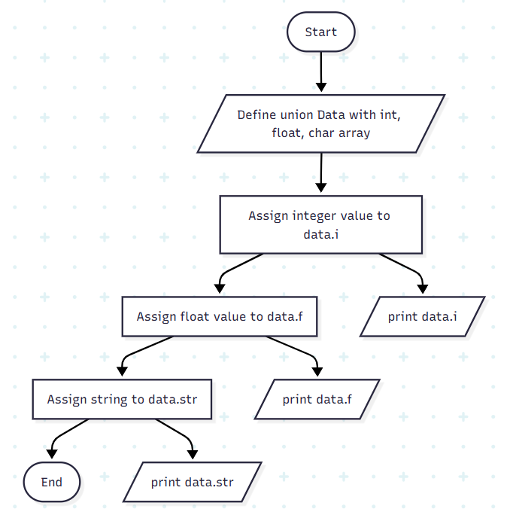
Program:
#include <stdio.h>
#include <string.h>
union Data{
int i;
float f;
char str[20];
};
int main(){
union Data data;
data.i = 10;
printf("data.i: %d \n", data.i);
data.f = 220.5;
printf("data.f: %f \n", data.f);
strcpy(data.str, "C Programming");
printf("data.str: %s \n", data.str);
return 0;
}
Output:
data.i: 10
data.f: 220.500000
data.str: C Programming
Result:
The program shows that in a union, all members share the same memory location, so assigning a new value overwrites the previous one.
==================================================
Ex.No: 19
Date:
To input and print array elements using a pointer
Aim:
To write a C program that inputs and prints array elements using pointers instead of array indexing.
Algorithm:
- Start the program.
- Define an integer array arr[MAX_SIZE] and a pointer ptr.
- Input the array size N.
- Set ptr = arr (so it points to the first element).
- Loop i = 0 to N-1:
- Use scanf("%d", ptr) to input values at the pointer’s location.
- Increment the pointer to move to the next element.
- Reset pointer ptr = arr (back to first element).
- Loop i = 0 to N-1:
- Print the value using *ptr.
- Increment the pointer.
- End program.

Flowchart:
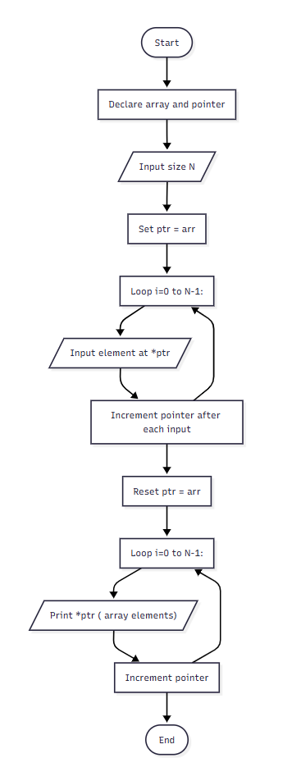
Program:
#include <stdio.h>
#define MAX_SIZE 100 // Maximum array size
int main()
{
int arr[MAX_SIZE];
int N, i;
int * ptr = arr; // Pointer to arr[0]
printf("Enter size of array: ");
scanf("%d", &N);
printf("Enter elements in array:\n");
for (i = 0; i < N; i++)
{
scanf("%d", ptr);
// Move pointer to next array element
ptr++;
}
// Make sure that pointer again points back to first array element
ptr = arr;
printf("Array elements: ");
for (i = 0; i < N; i++)
{
// Print value pointed by the pointer
printf("%d ", *ptr);
// Move pointer to next array element
ptr++;
}
return 0;
}
Output:
Enter size of array: 5
Enter elements in array:
56
89
12
6
7
Array elements: 56 89 12 6 7
Result:
Thus the program successfully demonstrates accessing arrays using pointers.
==================================================

Ex.No: 20
Date:
To create a file and store employee information
Aim:
To write a C program that demonstrates file handling by storing employee details (name, age, salary) into a file using fprintf().
Algorithm:
- Start the program.
- Declare variables for name, age, and salary.
- Open a file emp.rec in write mode using fopen().
- If file opening fails, display an error message and terminate.
- Input employee details from the user:
- Name
- Age
- Salary
- Write the entered details into the file using fprintf().
- Close the file using fclose().
- End the program.

Flowchart:
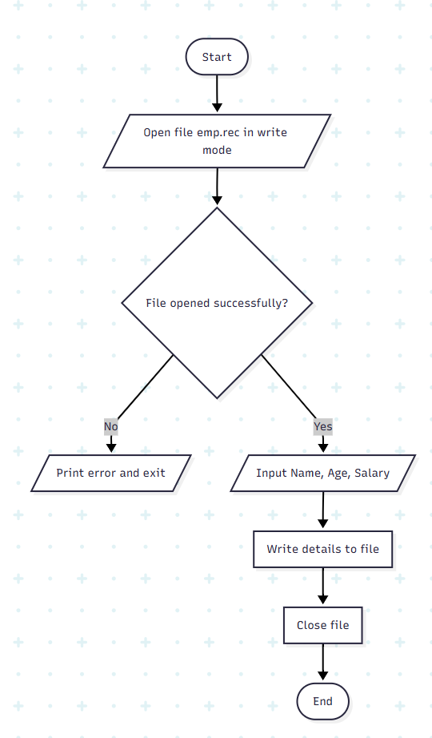
Program:
#include <stdio.h>
void main()
{
FILE *fptr;
char name[20];
int age;
float salary;
/* open for writing */
fptr = fopen("emp.rec", "w");
if (fptr == NULL)
{
printf("File does not exists \n");
return;
}
printf("Enter the name \n");
scanf("%s", name);
fprintf(fptr, "Name = %s\n", name);
printf("Enter the age\n");
scanf("%d", &age);
fprintf(fptr, "Age = %d\n", age);
printf("Enter the salary\n");
scanf("%f", &salary);
fprintf(fptr, "Salary = %.2f\n", salary);
fclose(fptr);
}
Output:
Enter the name
raj
Enter the age
40
Enter the salary
4000000
Result:
Thus, the program successfully demonstrates writing structured employee details into a file using C file handling functions.
==================================================

